**Laser Controller Prototype Development**

**Initial Brainstorming**

Early on, an initial controller program was sketched out using simple discrete control of the output variables. This code can be viewed in Appendix A and displays an attempt to control laser power and speed without controller algorithms. After implementing PID controllers as shown later, laser controller operation becomes more manageable and concise. This sketch is added on to later, is migrated to Arduino C++ , and is combined with PID controllers to implement a laser controller prototype.

As C++ is one of the most widely supported languages available, the choice of using it will allow the project to be utilized on a wide variety of microcontrollers with little to no changes to the code required. Additionally, if only a few parts of the application code are needed for a variation of the program, it will not be difficult to use them elsewhere.

**Laser Controller Prototyping**



Figure 1: The conceptual ALSS close-loop feedback control diagram, where R is the reference target (such as sintered NP resistivity, etc), Pav the laser power, v the laser scan speed, Va the actually detected signal voltage, Vm the model detection voltage, and C

Based off the initial control schema shown in Figure 1, a dual PID adaptive controller program was prototyped on a readily available Arduino Mega 2560. The prototyping was initially began on an Arduino Uno processor board, however, the need for additional flash memory for simulations arose, resulting in the Mega 2560 being used as it had sufficient flash memory to store static data to run simulations. Compared to the 32K bytes available on the Arduino Uno, the Mega 2560 offers eight times more flash storage (256K), giving us the flash memory necessary for our simulations.

Granted the hardware limitations of the Arduino platform in regards commercial platforms, the Arduino platform and similar microcontrollers will be adequate for our purposes. Ultimately, the algorithms written in C++ will be the baseline for adaptation and usage on full-scale commercial systems.

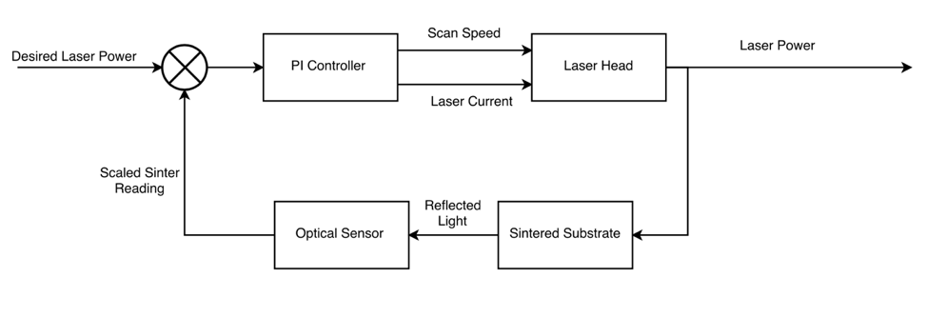

Figure 2: Simplified Single Input Multiple Output Closed Loop Feedback Control System

An open-source C++ PID library (see Appendix B) was used to create the PID controllers in the laser controller program (see Appendix C). This PID library offers live PID tuning methods allowing the PID parameters to be altered while the laser is operating to suit the oxidation constraints based off of signal feedback whether from a light detector or thermal imaging camera in further prototyping.

**Adaptive Logic**

As mentioned before, the adaptive algorithm component from the initial control schema was simplified to a simple inline logic component to be built into the Arduino controller program. This adaptive piece which varies the scan speed within a calculated range of values for oxidation-free operation given a particular current is shown in Figure 2. The adjustSpeedPIDBoundaries() function calculates speed output minimum and maximum values given a current output level by the current PID controller. Due to inconclusive results from signal extraction tests, the empirical relationship trends between the laser current and scan speed for oxidation boundaries cannot be used here. Arbitrary trend slopes and offset are used as placeholders until more definitive relationships are solidified in Phase II.

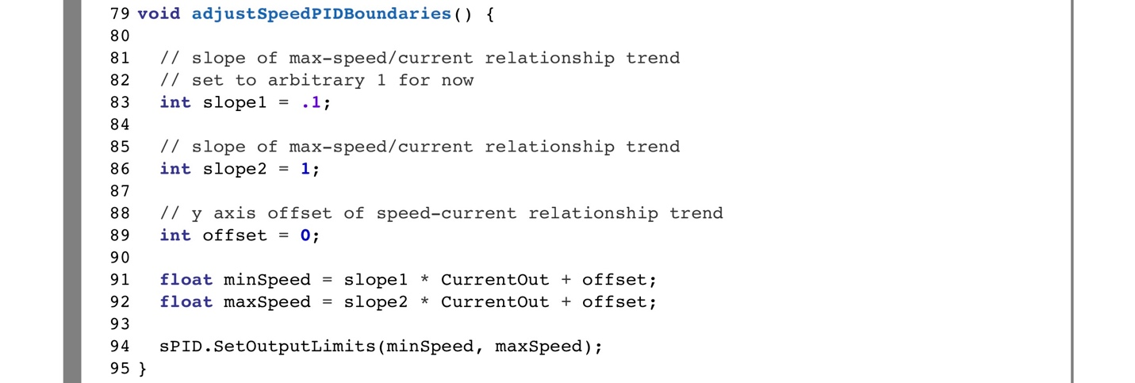

Figure 3: Adaptive logic for calculating laser speed from the laser current ensuring oxidation levels are never reached.

A second adaptive component makes use of dynamic controller parameters to improve response time. An error gap is defined within which the current controller will operate under a set of conservative parameters, outside which the controller will operate under a set of aggressive parameters. This allows the controller to reach a laser current output more quickly with the aggressive constants when it is far away from the desired setpoint value (SP) and operate more slowly with the conservative values when it is near the SP.

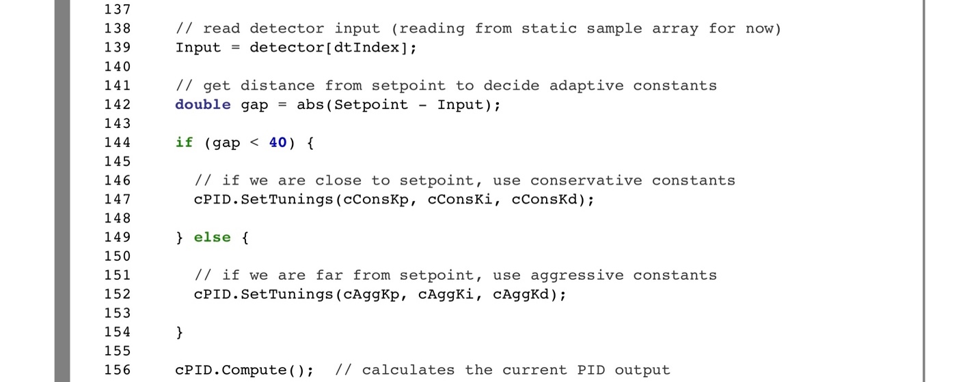

Figure 4: Adaptive logic for using dynamic controller parameters. cConsKx values are the conservative current controller parameters to use if within the defined error gap. cAggKx values are the aggressive current controller parameters to use if outside the defined error gap.

**Controller Parameters**

The controller parameters used for the scan speed and current PID controllers are denoted with the standard symbols: Kp for the proportional gain constant, Ki for the integral gain, and Kd for the derivative gain (in the program and simulation plot consKx and aggKx are used to denote the aggressive and conservative values). The proportional gain constant (Equation 1) acts similarly to the additional adaptive component explained earlier; the larger the difference between the setpoint (SP) and feedback process variable (PV) the more drastically the controller will change the output in order to achieve the SPs value. The adaptive component which uses a defined error gap to switch between aggressive values and conservative values improves on this for the Kp constant and applies this principle across the other constants as well.

$P-Term = Kp ∙ e (t)$**Equation 1**

The integral gain constant (Equation 2) helps to compensate for error that existed in previous PV values. Depending on how fast the laser head will eventually be moving, the integral gain constant may not be necessary. For example, if the laser controller were unable to properly sinter one section of a conductor trace, by the time the feedback reaches the controller it may not be beneficial to compensate for the under-sintered section by over-sintering the next section. However, this is only an issue if the laser head is travelling quickly. At slower speeds it is much less of a problem though because in reality the laser deposits energy across an area of conductor material not just a point, meaning that the next section that the laser is sintering will be a gradient from the previous under-sintered section to a new un-sintered section.

$I-Term= \int_{0}^{ τ}{Ki∙e\left(t\right) dt}$**Equation 2**

The derivative gain constant (Equation 3) helps to predict when the controller’s PV is about to reach the SP value. For example, if a series of PV data points indicated a sharp rise in error above the desired SP sinter level, with error defined as (SP – PV), this would render a large negative slope for the error making the derivative gain constant a larger negative value. If the PV signal then began to decrease and slowly approach the SP value, the derivative gain constant would become a smaller positive value as the error is approaching zero from a negative axis. This essentially means that the derivative gain constant will influence the output towards the SP when the PV is straying from the SP and will try to influence the output away from the SP when the PV is approaching the SP. This helps to counterbalance overshoot that can occur with the integral and proportional terms and helps the controller to reach a steady state quicker.

$D-Term=Kd ⋅ \frac{d e(t)}{dt}$**Equation 3**

Adding all the terms together forms the equation (Equation 4) for the controller’s output which is implemented in the Arduino PID library mentioned earlier.

$Output(u)= Kp∙e \left(t\right)+ \int_{0}^{ τ}{Ki∙e\left(t\right) dt}+ Kd ⋅ \frac{d e(t)}{dt}$**Equation 4**

**Static Data Simulation**

Results from one of the photodetector readouts from signal extraction tests were used to simulate the laser controller’s response given a static open-loop set of data to react to. An arbitrary controller setpoint of 4.8V was chosen based off of where the photodetector’s results appear to plateau off in a section that was known to be fully sintered. An array was then loaded with the dataset obtained from the photodetector, and the controller’s setpoint set at 93 (corresponding scaled integer value for the 4.8V). Because the microcontroller currently being used for prototyping is limited on flash memory, both the speed and current controllers’ output limits within the program were set to an integer range that could fit in a byte (0 – 255) and converted to scaled float values after the simulation and before plotting. In a full closed-loop test, the current controller output limits would be set from 200 to 800 for example to represent the desired range of milliamps for the laser to consume. The laser speed controller would then be calculated off of the current controller’s output with the adaptive adjustment function shown in Figure 2.

With this basic setup however, results in Figure 4 were able to be obtained. The simplified algorithm the Arduino program runs through to obtain a simulated plot like this is as follows:

1. Define variables, constants, and PID controllers
2. Initialize PID controllers
3. Load static datapoint *x*  into input variable.
4. If (setpoint – input) difference is greater than our defined gap, then use aggressive current controller parameters, else use conservative values.
5. Run current controller computations
6. Run adaptive scan speed function
7. Run scan-speed controller computations
8. Increment x and start over at step 3.

The scan speed adaptation function wasn’t used for these simulations due to the memory limitations of the microprocessor. Altering the scan-speed controller limits would The orange and blue plotlines display how the dual controller responds with the speed and current output variables given the pre-recorded static open-loop feedback from the detector (black dotted line). When the feedback signal is below the setpoint value (straight black solid line), the current (blue line) is increased and the scan speed (orange line) is decreased. Because the controller is not yet actually controlling any real outputs that affect the input feedback signal, the response is still noisy as is the input. Once the prototype controller is implemented on the laser system, the feedback signal line would ideally smooth out as the controller is working to stabilize the photodetector feedback. Depending on whether or not the reflectivity feedback is determined to be a suitable signal or not, this may be irrelevant. The same controller operation would apply however for any feedback signal proportional to sintering completion that can be obtained. Additionally, the method for feeding in the static simulation data needs to be refactored to align the sample feed rate with the PID calculation rate; this would give more accurate derivative gain constant to help with smoothing out the controller signal.

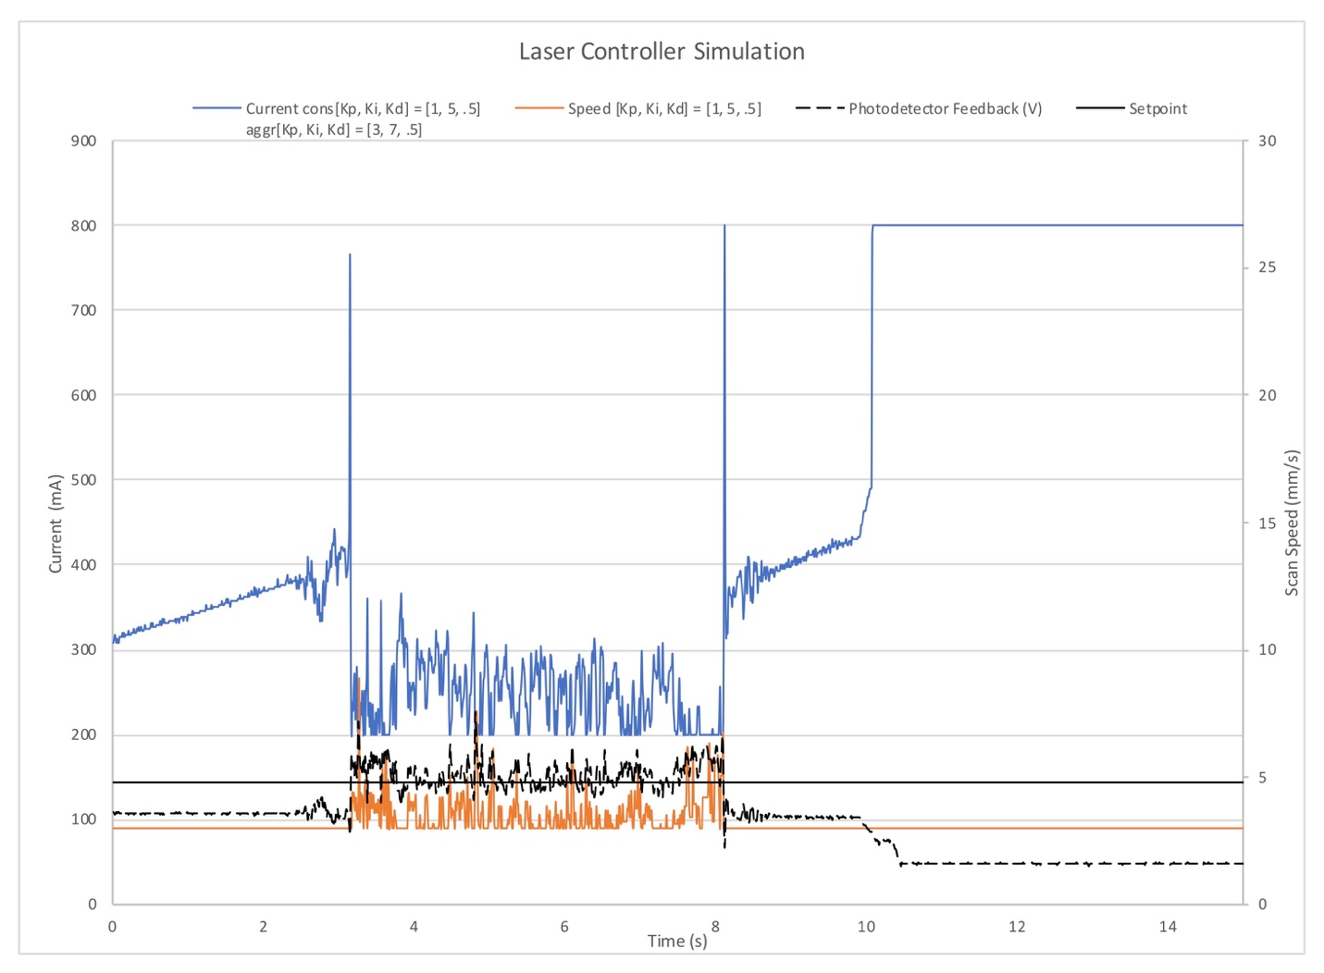

Figure 5: Plot of laser controller outputs (current output control – orange line; scan speed output control – blue line) when feeding in static open-loop data (dotted black line) from signal extraction tests.

**Appendix A: Initial Laser Controller Sketch**

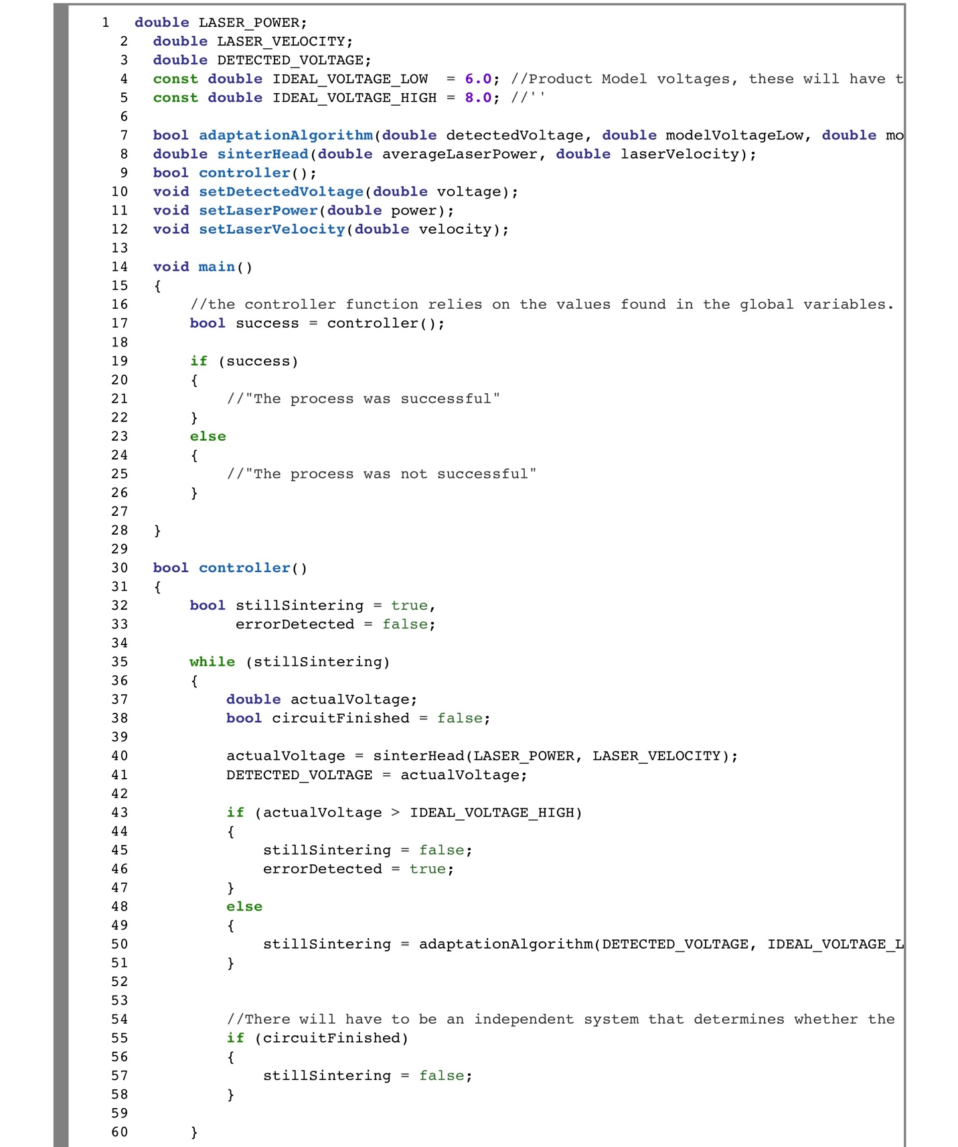

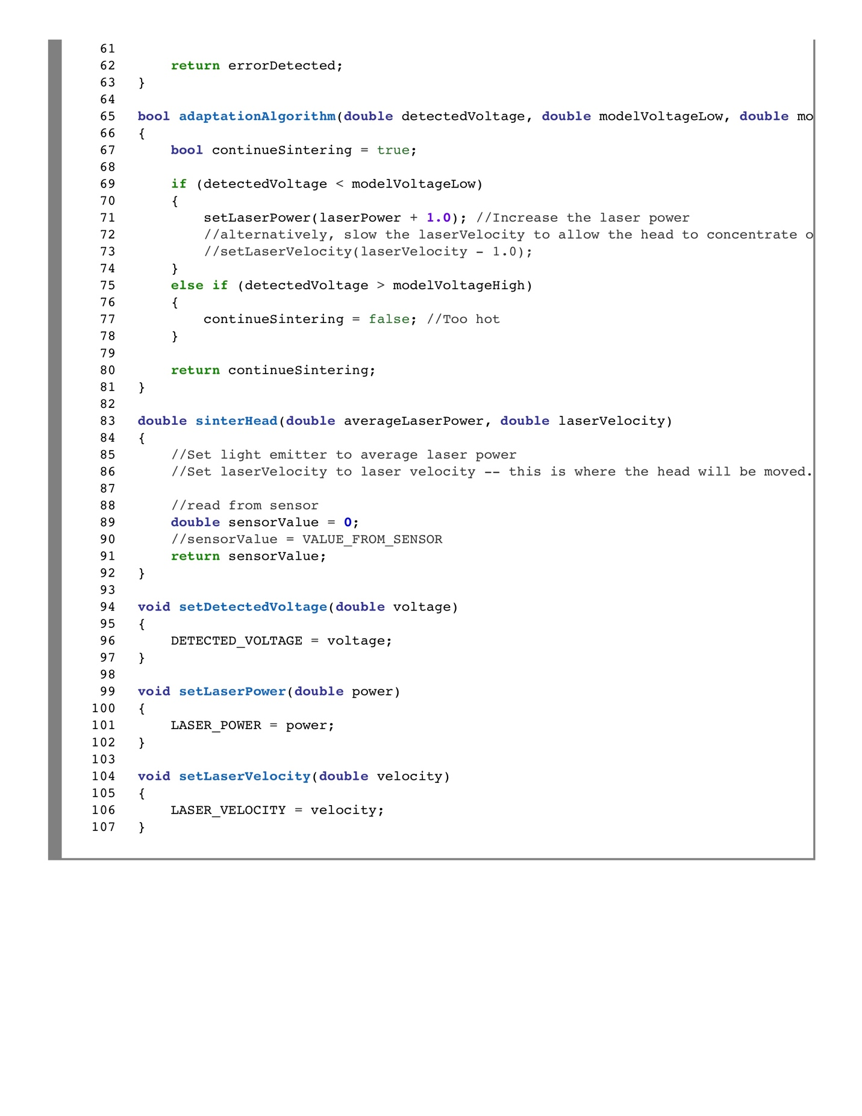

**Appendix B: C++ PID Library implementation File**

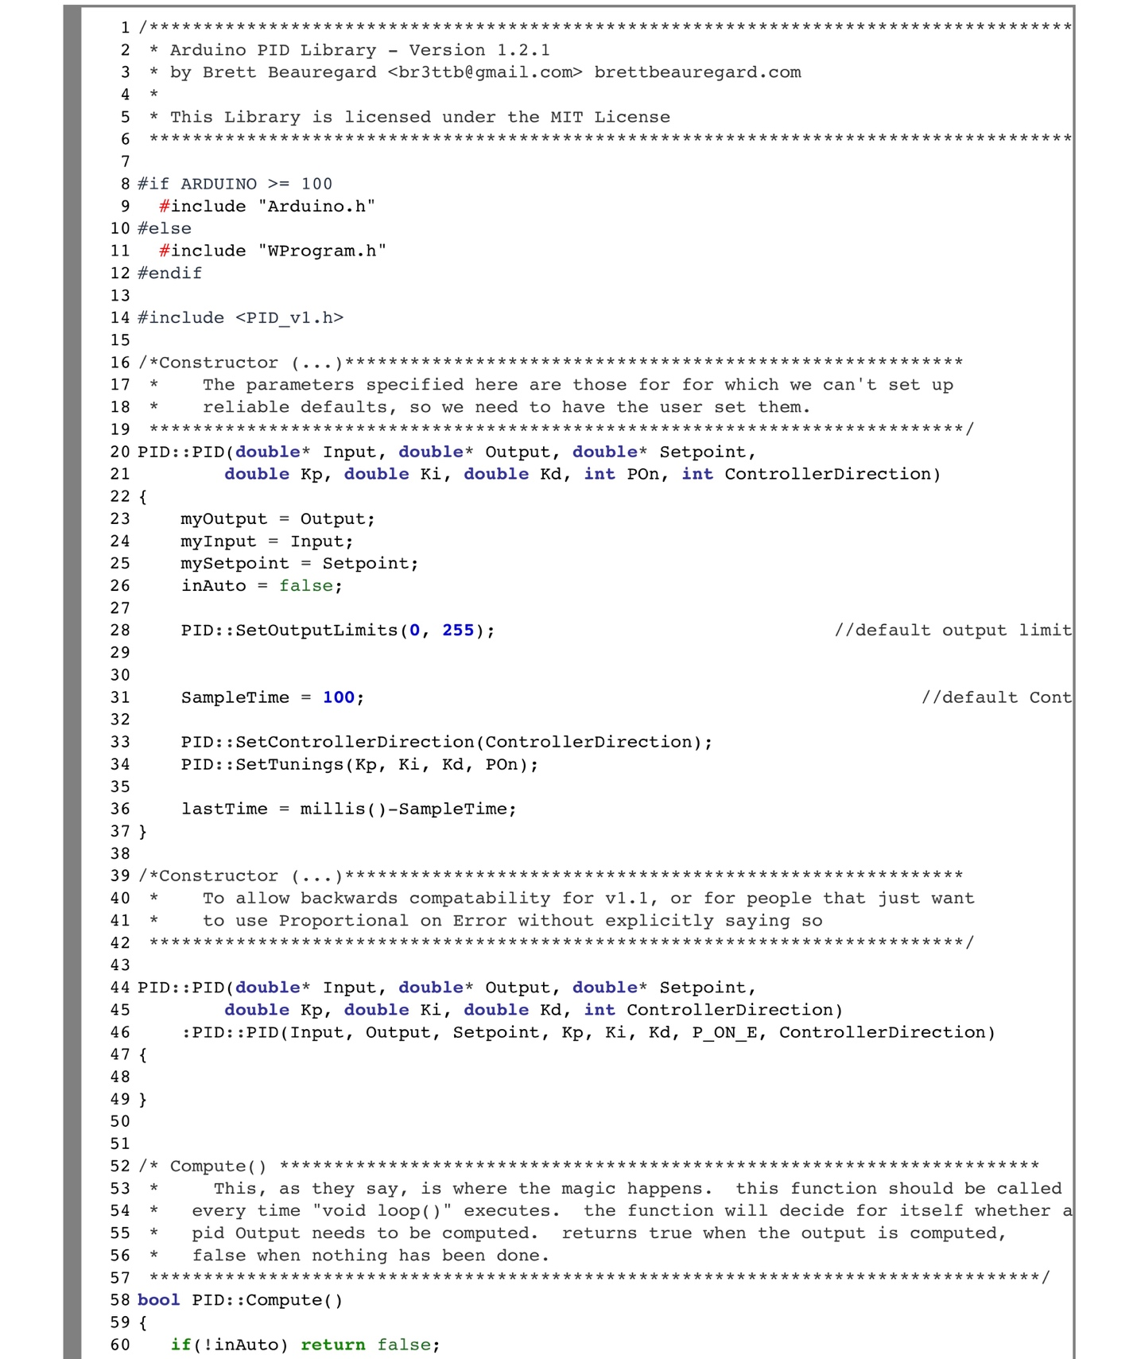

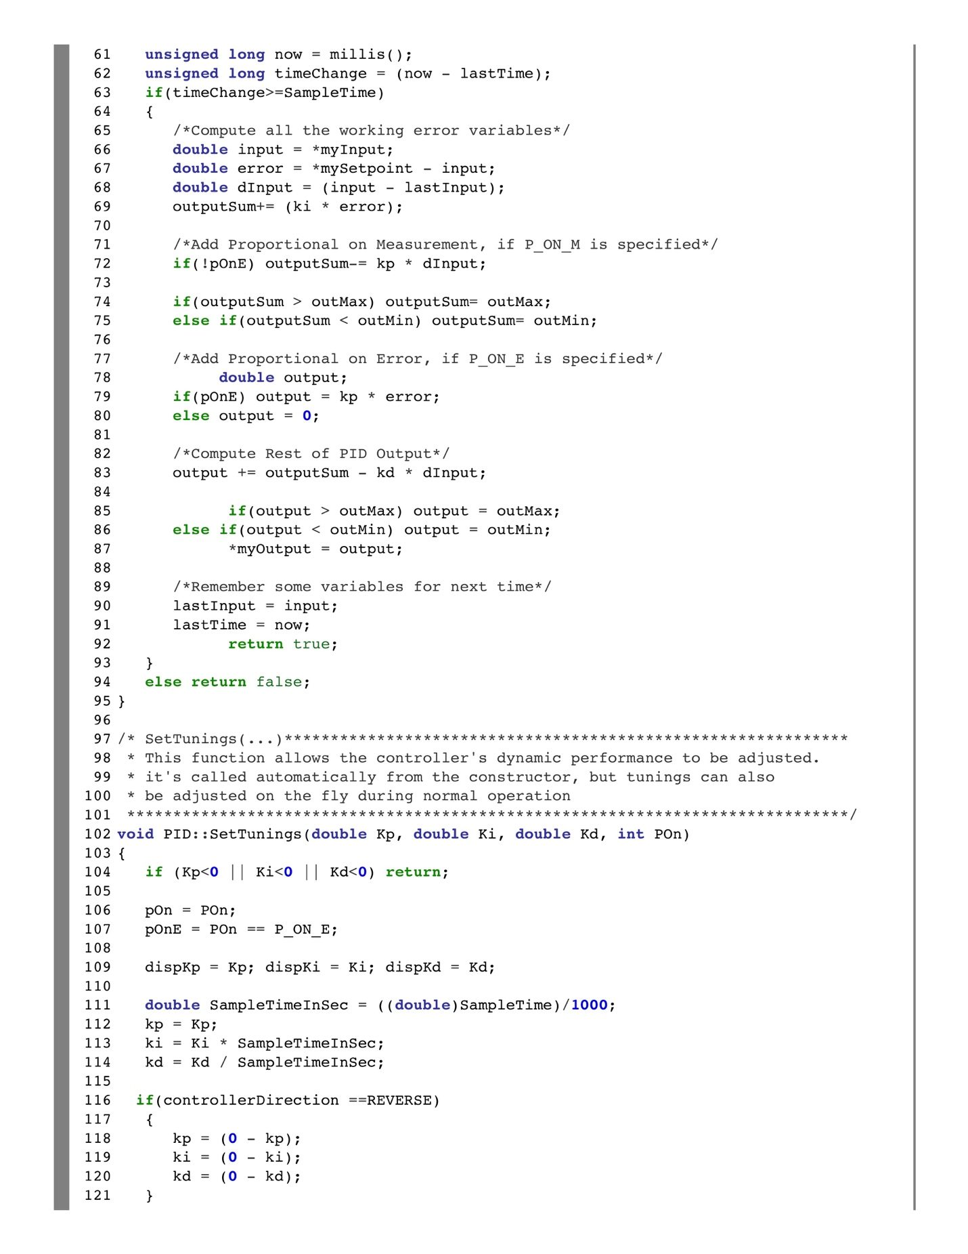

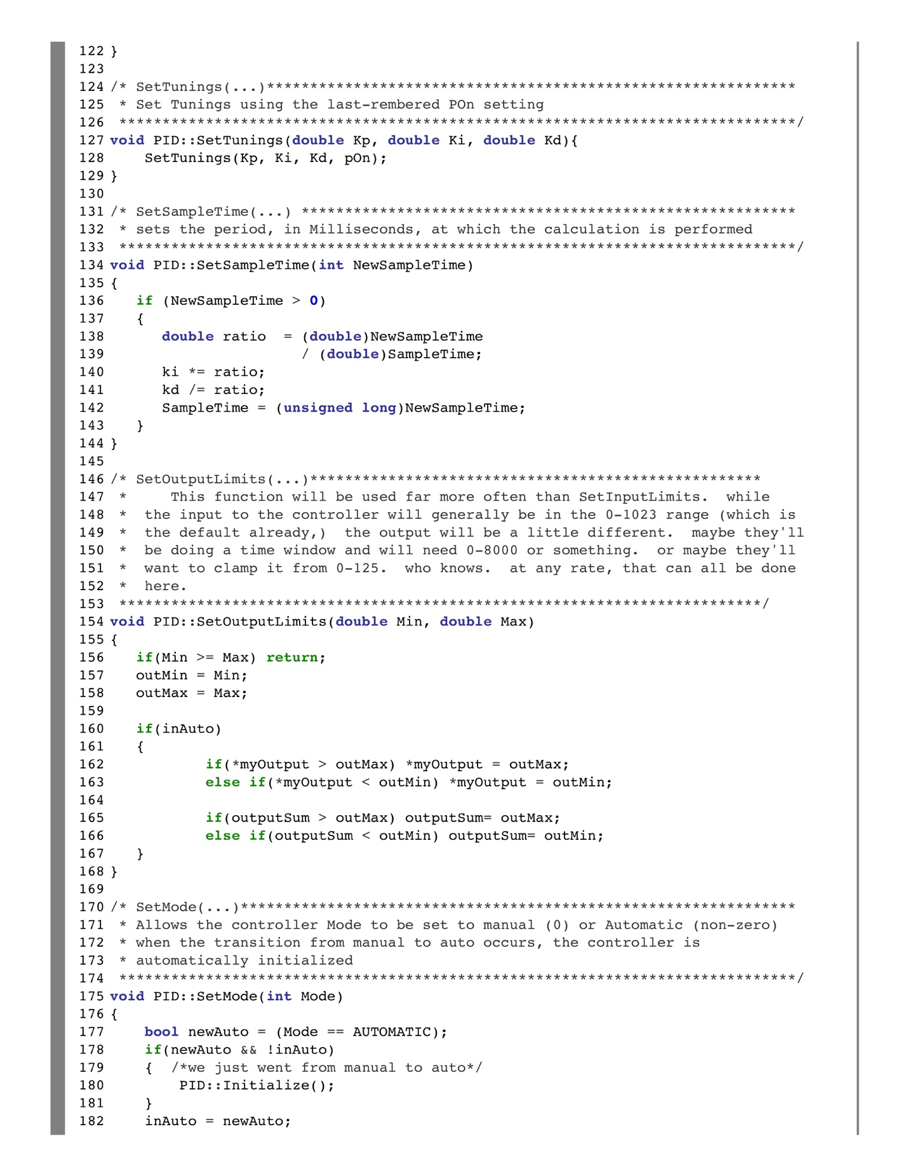

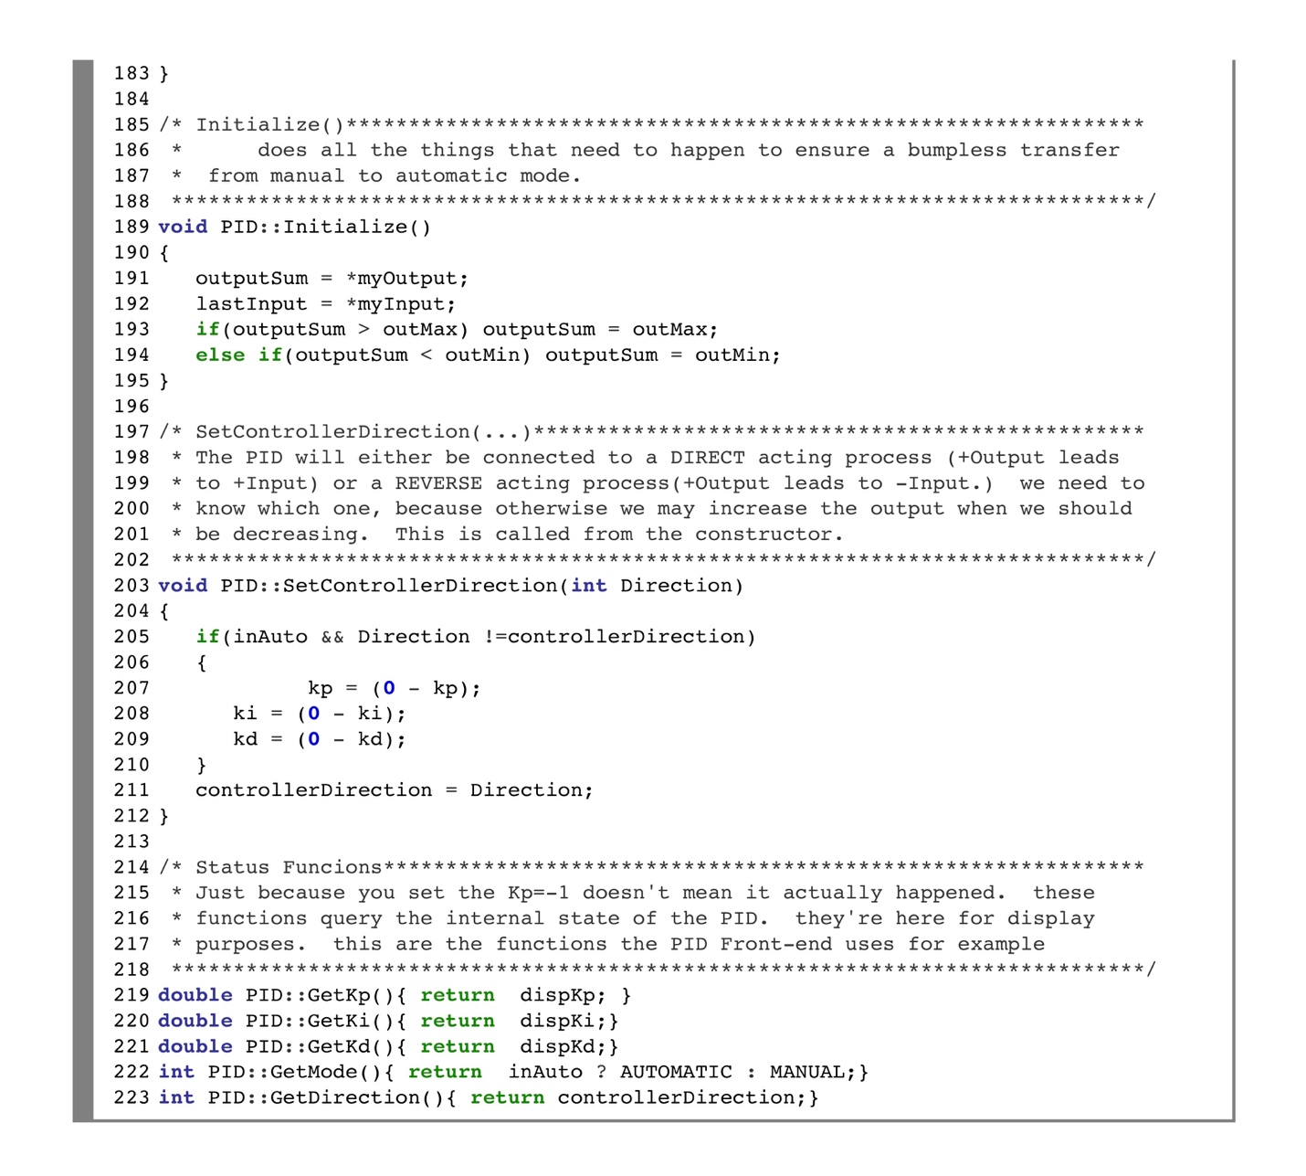

**Appendix C: Arduino Laser Controller Program**

The implementation file for the laser controller program is shown below

